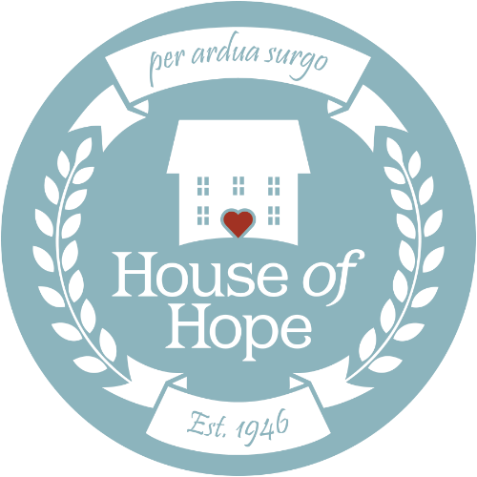

House of Hope Custom Social Media Prompts
Please use these prompts as a starting place to share on your social media network alongside your peer-to-peer fundraiser or to announce your participation in the virtual 5k on October 3, 2020.
Peer-to-Peer Fundraising Campaign
- I’m raising money for House of Hope to support women and children in recovery! This cause is important to me because…
- I’m fundraising for House of Hope. Their mission is treating substance use disorders, rebuilding lives, strengthening families, and empowering women. I think their mission is worth supporting because…
- I’m raising money for House of Hope, Utah’s oldest provider of substance use disorder treatment. Even small donations make a difference and will help me achieve my goal of _____. House of Hope is worth donating to because…
5k Participation Announcement
- On October 3, I’ll be participating in a virtual 5k to raise awareness for House of Hope. I chose to participate because…
- House of Hope is Utah’s oldest provider of substance use disorder treatment. I’m participating in their virtual 5k on October 3! I think you should join me in this virtual 5k because…
Be sure to tag @HouseofHopeUT in all your posts—we love to hear why people are excited about our mission!

